**Problem Definition**

In this project we are required to make a controlled rectifier that will be used to drive a DC Motor.

* Power Input: 3 Phase, or 1 Phase AC Grid (Adjustable with variac)
* Output: Adjustable DC Output (Vmax < 180 Vdc)

Specs of all motor windings are measured as follows:

* Armature Winding: 0.8 Ω, 12.5 mH
* Shunt Winding: 210 Ω, 23 H
* [Interpoles](https://www.quora.com/Electrical-Machines-What-do-interpoles-do-in-DC-motors) Winding: 0.27 Ω, 12 mH
* Inertia: TBA

**Analytical Calculations**

***Buck Converter Design***

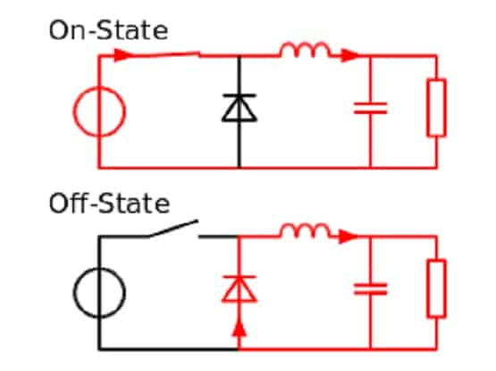

*Basic circuit model of a buck converter at on and off states in CCM*

On state:

$$V_{d}-V_{o}= V_{L} and i_{c}=i_{L}-\frac{V_{o}}{R}$$

Off state:

*Voltage and current waveform models of the buck converter*

$$\begin{matrix}A(ON) \\ {(V}_{in}-V_{o})DT_{S}\end{matrix}=\begin{matrix}B(OFF) \\ V_{o}(1-D)T_{S}\end{matrix}$$

$$V_{in}D- V_{O}D=V_{o}-V_{o}D$$

$$V_{o}= V_{in}D$$

$$0≤ V_{o}≤ V_{in} and I_{o}=\frac{I_{d}}{D}$$

Since our motor input (Vo) should be smaller than given 180 V maximum level,

$$180> V_{in}D$$

Due to nonideal performance conditions, having 1 or 0 duty cycle is not easy to satisfy. Thus,

$$0.2≤D≤0.8 will be much more valid$$

Hence, we can define a condition for the input voltage of the buck converter $(V_{in})$ as

$$\frac{180}{D}> V_{in}→\frac{180}{0.8}> V_{in}→ V_{in}<225 V$$

*Throughout the function of the buck converter, we also estimated the minimum inductance value to stay in Continuous Current Mode:*

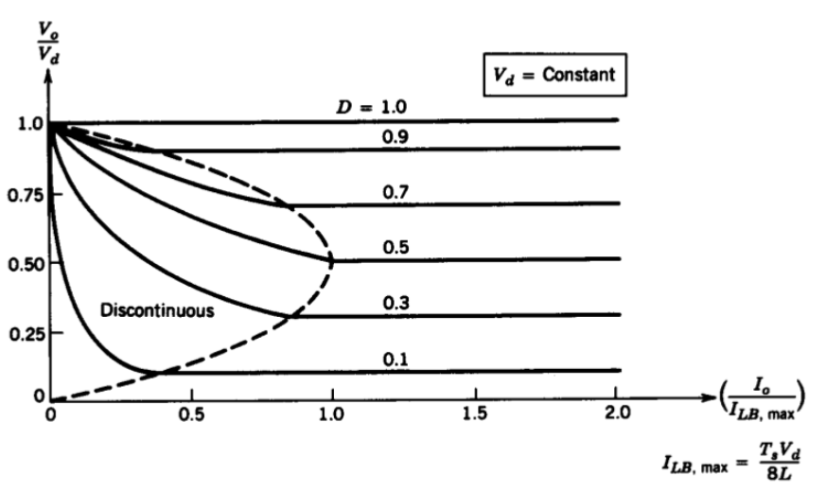

*Output voltage and current relations at Continuous and Discontinuous Conduction Modes*

As it can be observed, the critical current value occurs when D = 0.5

$$Assuming I_{LB}= \frac{i_{L,peak}}{2} as I_{LB}= \frac{t_{ON}(V_{d}-V_{o}) }{2L} with t_{ON}=DT_{S}$$

$$Then I_{LB}= \frac{DT_{S} \left(V_{d}-V_{o}\right)}{2L}→ Inserting D=0.5 I_{LB,MAX}= \frac{T_{S}V_{d} }{8L}=\frac{V_{d} }{8Lf_{S}}$$

$$also V_{o}=DV_{d}$$

$$I_{LB}= \frac{DT_{S} (1-D)V_{d} }{2L}= \frac{T_{S} (1-D)V_{O} }{2L} = \frac{ (1-D)V_{O} }{2Lf_{S}}$$

$$thus, minimum inductance for CCM: L_{min}= \frac{ (1-D)V_{O} }{2{I_{LB}f}_{S}}= \frac{ (1-D)Z_{load} }{2f_{S}}$$

Foer our case D = 0.5, by given armature impedance of the motor and assuming our frequency range 1-5 kHz it is obtained that

$$L_{min}= \frac{ Z_{load} }{4f_{S}}≈\frac{0.8Ω }{4*1000}=0.2 mH$$

$$and I_{LB,MAX}=\frac{V_{d} }{8Lf_{S}}=\frac{225 V}{8*0.2mH*1kHz}<given motor current data=23.4 A$$

Meaning that throughout our duty cycle choices, even if we do not implement an additional inductor since there is already an inertial inductance of the motor, which is higher than 0.2 mH, we will be in a safe zone for the continuous conduction mode.

*Voltage Ripple for the Buck Converter:*

$$∆Q= \frac{\frac{∆I_{L}}{2}*\frac{T_{S}}{2}}{2}=\frac{T_{S}(∆I_{L})}{8}$$

$$also ∆V_{o}= \frac{∆Q}{C}→ ∆V_{o}= \frac{T_{S}(∆I_{L})}{8C}$$

By using off time ratio (1-D) it is obtained that

$$∆I_{L}= \frac{V_{o}(1-D)T_{S}}{L} since i_{L}=\frac{1}{L}\int{V_{L}dt}$$

$$Then we get ∆V_{o}= \frac{T_{S}V_{o}(1-D)T_{S}}{8LC}$$

$$and ripple→ \frac{∆V_{o}}{V_{o}}=\frac{(1-D)T_{S}^{2}}{8LC}= \frac{(1-D)}{8LCf_{S}^{2}}$$

For worst case scenario, by taking as $D=0.2, { f}_{S}=1kHz, L=12. 5 mH by only armature$

$$Ripple ≈ \frac{0.8}{8*12.5mH*{1000}^{2}*C}=\frac{8 x {10}^{-6}}{C}$$

At this point, increasing the frequency or implementing extremely high capacitor would have been expected as possible solutions. However, increasing the frequency means also increasing the switching losses, which can be found in the thermal analysis part, and it can disturb the thermal limit of our components. Moreover, a small capacitance will not be enough to obtain a reasonable ripple range, much higher value can balance that, yet this will cause higher cost and sizes in our design which may not be applicable under experimental conditions. Thus, it is currently considered that the internal capacitance of the motor will satisfy our conditions. Besides, if it seems necessary during test periods, by choosing 3.3 µF capacitor will be placed.

Hence the ripple is obtained as

$$\frac{8 x {10}^{-6}}{C}→\frac{8 x {10}^{-6}}{3.3 x {10}^{-6}} ≅2.42 V$$

which can be accepted as small in the range of our motor input.

***Rectifier Design***

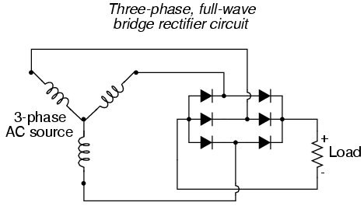

*The circuit connection model of three phase full bridge rectifier design*

As it was found previously on the buck converter design part that

$$V_{in}<225 V for the motor$$

Since the input voltage of the buck converter is supplied by the output voltage of the rectifier,

$$V_{out}<225 V for the rectifier$$

By Yn configuration, the necessary input voltage for the rectifier can be estimated as

$$V_{out}= \frac{3\sqrt{2}}{π}V_{l-l}<225 V→V_{l-l}<\frac{225*π}{3\sqrt{2}} ≅166.6 V$$

$$and V_{in,phase}=\frac{166.6}{\sqrt{3}} V$$